**Chapter 9 - Travel and Tourism**

**All Lectures Uploaded on YouTube:** [**https://tinyurl.com/fkm9-english**](https://tinyurl.com/fkm9-english)

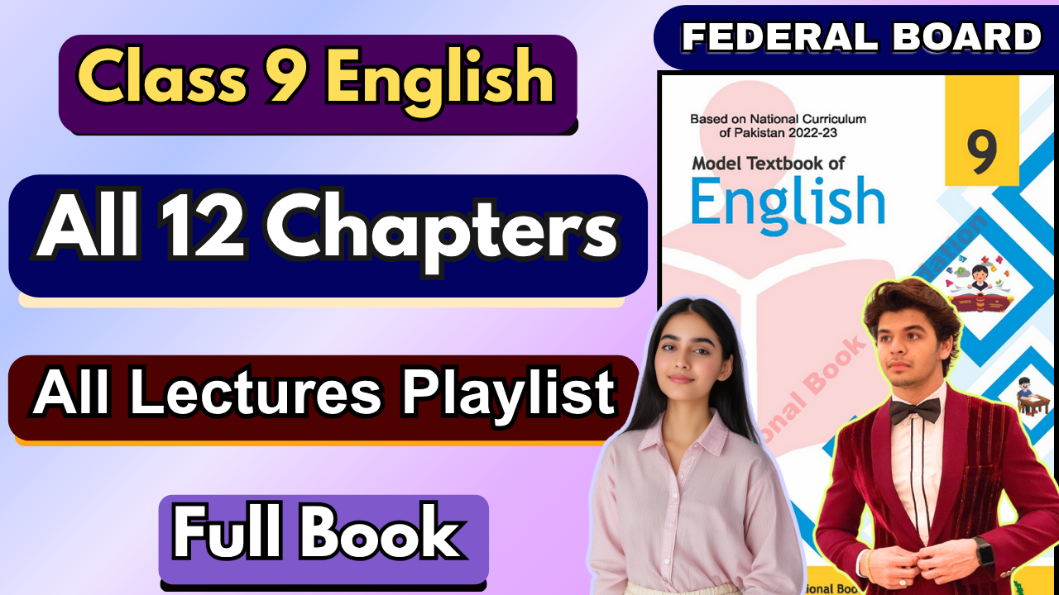

# 

**Glossary:**

**Given below are the difficult words from the unit. Look at their meanings and use these words in your own sentences.**

| **Words** | **Meaning** |
| --- | --- |
| anchored | fixed in place, typically referring to a boat or ship |
| minaret | a tall, slender tower, typically a part of a mosque. |
| blows | the act of striking or hitting something with force |
| knotty | having knots or having many twists, turns, or complications |
| flamingo | a tall, wading bird known for its long legs, pink or reddish plumage, and distinctive curved beak |
| devouring | eating or consuming something with great eagerness |
| palanquin | a covered litter carried by several people, typically with long handles on each side |
| gloom | state of darkness, a feeling of sadness, or a general sense of foreboding or unhappiness |
| deserted | abandoned or empty |
| caravan | a group of travelers, across deserts or remote areas |



The following are the sentences for the above mentioned words:

1. **Anchored** – The ship was **anchored** safely in the harbor before the storm began.
2. **Minaret** – The tall **minaret** of the mosque gleamed under the golden rays of the setting sun.
3. **Blows** – The cold wind **blows** fiercely across the mountain pass every winter.
4. **Knotty** – The carpenter struggled to cut through the **knotty** piece of wood.
5. **Flamingo** – A graceful **flamingo** stood on one leg by the shimmering lake.
6. **Devouring** – The lion was **devouring** its prey after a long and exhausting hunt.
7. **Palanquin** – The queen was carried through the streets in a golden **palanquin** adorned with silk curtains.
8. **Gloom** – A deep **gloom** settled over the town after the sun disappeared behind the clouds.
9. **Deserted** – The streets were **deserted** after midnight, with only the sound of the wind echoing through them.
10. **Caravan** – A **caravan** of traders crossed the vast desert, their camels laden with spices and fabrics.

**Reading and Critical Thinking Skills**

**A. Reading Comprehension Questions:**

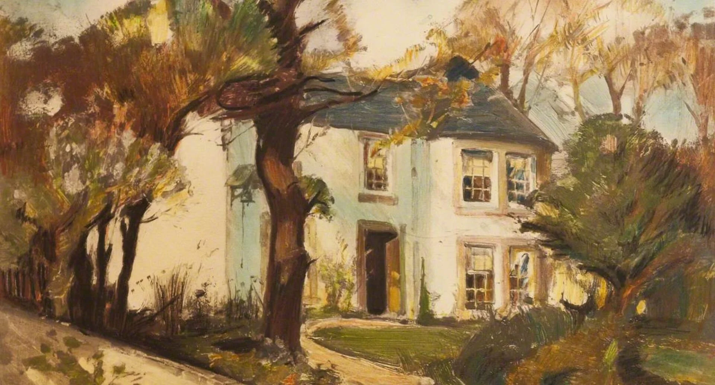

**Question 1: How does the poet describe the allure of travel in the first stanza?**

**Ans.** The poet conveys the allure of travel by describing magical and exotic places like "where the golden apples grow" and "parrot islands anchored." These images evoke a sense of wonder and excitement.

**Question 2: What is the rhyme scheme of the poem?**

**Ans.** The rhyme scheme is consistent.

**Question 3: What are your thoughts about the imagination of an innocent young boy who wants to explore the world?**

**Ans.** The young boy's imagination represents innocence, curiosity, and a thirst for adventure. His dreams highlight how travel and discovery fuel creativity and inspire a sense of freedom.

**Question 4: What is the central theme of Robert Louis Stevenson’s poem "Travel," and how does the poet convey this theme through poetic devices?**

**Ans.** The central theme is the longing for exploration and experiencing the beauty of diverse cultures and landscapes. The poet uses vivid imagery, metaphors (e.g., "tall as a spire"), and symbolism to convey his dream of travel and adventure.

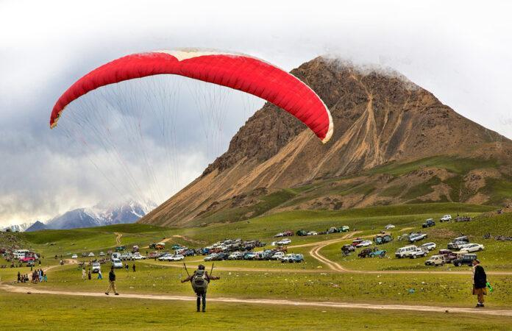

**Question 5: Which figurative device is used by the poet in the line "wide as England, tall as a spire"? Explain briefly.**

**Ans.** The poet uses a **simile**, comparing the width of forests to England and their height to a spire, emphasizing their vastness and grandeur.

## Question 6: Analyse the poem with the help of starters:

**Ans.**

* In the first stanza, the poet talks about magical lands filled with beauty and wonder.
* The tone of the poem is adventurous and imaginative.
* The concluding lines of the poem talk about exploring historic places, exotic animals, and deserted cities.

**Direct/Indirect Speech:**



# Direct Speech

In **direct speech**, the exact words spoken by a person are quoted, often enclosed in quotation marks. The speaker's words are presented as they were originally spoken.

* Example:
  + She said, **"I am going to the market."**

**Indirect Speech**

In **indirect speech**, the speaker's words are reported without quoting them directly. The sentence structure and pronouns often change, and quotation marks are not used. Words like "said," "told," or "asked" are often used to introduce the speech.

* Example:
  + She said **that she was going to the market.**

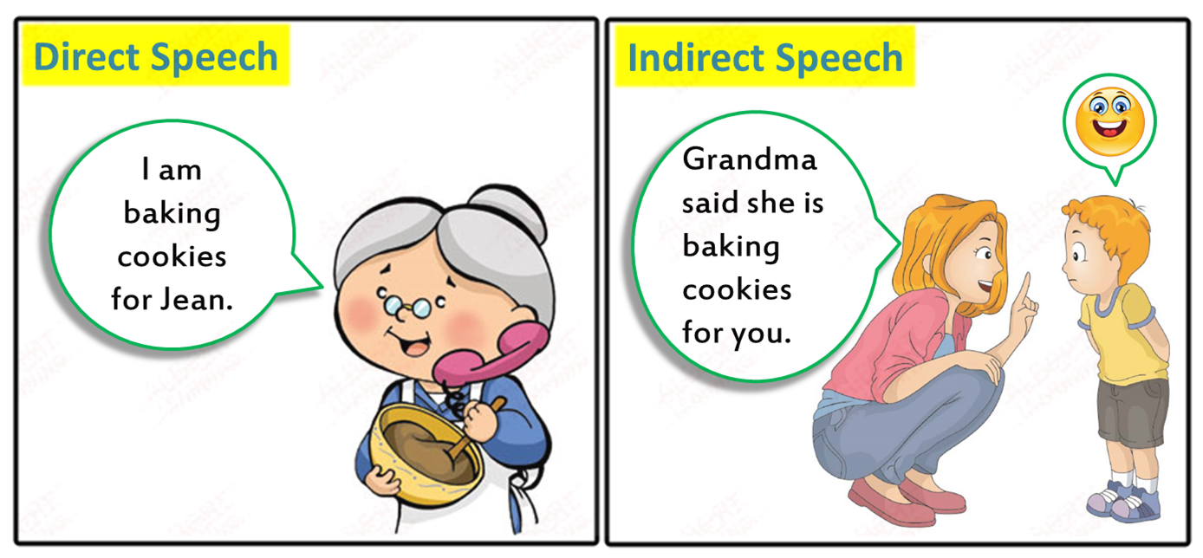

## Exercise:

**Change the narration of the following sentences.**

1. **Direct Speech**: He said to me, "How long will you stay here?"  
   **Indirect Speech**: He asked me how long I would stay there.
2. **Direct Speech**: Pamela said, "Man is mortal."  
   **Indirect Speech**: Pamela said that man is mortal.
3. **Direct Speech**: He said to her, "What a cold day!"  
   **Indirect Speech**: He exclaimed that it was a very cold day.
4. **Direct Speech**: The man said to the officer, "Please help me."  
   **Indirect Speech**: The man requested the officer to help him.
5. **Direct Speech**: She asked me, "Are you happy in your new job?"  
   **Indirect Speech**: She asked me if I was happy in my new job.
6. **Direct Speech**: He said, "My father is a doctor."  
   **Indirect Speech**: He said that his father was a doctor.
7. **Direct Speech**: She said to me, "Do you want something?"  
   **Indirect Speech**: She asked me if I wanted something.

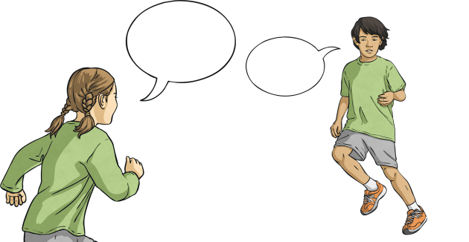

1. **Direct Speech**: She says, "I will clear the exam in my very first attempt."  
   **Indirect Speech**: She says that she will clear the exam in her very first attempt.
2. **Direct Speech**: "Don’t waste time," the teacher said to the students.  
   **Indirect Speech**: The teacher told the students not to waste time.
3. **Direct Speech**: John said to his mother, "I shall go to bed now."  
   **Indirect Speech**: John told his mother that he would go to bed then.
4. **Direct Speech**: He said to me, "May you be happy."  
   **Indirect Speech**: He prayed that I might be happy.
5. **Direct Speech**: The mother said to the child, "Don’t go out."  
   **Indirect Speech**: The mother told the child not to go out.
6. **Direct Speech**: They said, "Long live the king."  
   **Indirect Speech**: They prayed that the king might live long.
7. **Direct Speech**: They said, "Hurrah! We have won the match."  
   **Indirect Speech**: They exclaimed with joy that they had won the match.
8. **Direct Speech**: The old man said, "I am feeling better now."  
   **Indirect Speech**: The old man said that he was feeling better then.

**Practice Questions:**

1. **Convert the following direct speech into indirect speech:**
2. She said, "I am going to the store."
3. He said, "I will call you later."
4. "I have finished my homework," she said.
5. "Do you like my new dress?" she asked.
6. "We are leaving for the airport tomorrow," they said.
7. Mimi said, “I have been writing this letter.”
8. I said, “Sam’s driving the car.”
9. My uncle said, “I am cooking lunch.”
10. My brother said, “I have already eaten.”
11. The old lady said to the girl, “Where do you come from?”

**Ans.**

1. She said that she was going to the store.
2. He said that he would call me later.
3. She said that she had finished her homework.
4. She asked if I liked her new dress.
5. They said that they were leaving for the airport the next day.
6. Mimi said that she had been writing that letter.
7. I said that Sam was driving the car.
8. My uncle said that he was cooking lunch.
9. My brother said that he had already eaten.
10. The old lady asked the girl where she came from.

# Convert the following indirect speech into direct speech:

1. He told me that he was feeling sick.
2. She asked if I had seen her keys.
3. They said that they would arrive at 6 p.m.
4. The teacher told the students to complete the assignment.
5. He said that he had completed the report.

**Ans.**

1. He said, "I am feeling sick."
2. She asked, "Have you seen my keys?"
3. They said, "We will arrive at 6 p.m."
4. The teacher said, "Complete the assignment."
5. He said, "I have completed the report."

**3. Identify whether the following sentences are in direct or indirect speech:**

1. He asked, "Where are you going?"
2. She told me that she had visited Paris.
3. "What time is the meeting?" she asked.
4. They said that they would be arriving soon.
5. "I love this book," he said.

**Ans.**

1. Direct speech
2. Indirect speech
3. Direct speech
4. Indirect speech
5. Direct speech

